

Programme : Bachelor of Computer Science (Data Engineering)
Subject Code : SECP2753
Subject Name : Data Mining
Session-Sem : 2024/2025-2

Group Members:
Name | Matric Number
LAU YAN KAI | A23CS0098
CHEW CHIU XIAN | A23CS0061
NG YU HIN | A23CS0148

Table of Contents

Introduction 3
Business and Data Understanding 4
Problem Statement 4
Dataset Overview 5
Attribute Summary 5
Classification Models Selected for Analysis 7
Data Preparation and Preprocessing 8
Checking for Missing Values 8
Data Cleaning 8
Data Preparation 10
Encoding Categorical Variables 10
Correlation Matrix and Heatmap 11
Model Development 12
care_options 13
Logistic Regression 13
Decision Tree 14
Random Forest 15
Comparison between Models 16
treatment 17
Logistic Regression 17
Decision Tree 18
Random Forest 19
Comparison between Models 20
family_history 21
Logistic Regression 21
Decision Tree 22
Random Forest 23
Comparison between Models 24
Model Performance and Evaluation 25
Conclusion 26
References 27

Introduction
This project uses a real-life dataset from a survey about mental health in the tech industry. The survey has over 1,200 answers from people who work in technology jobs around the world. It includes about 25 pieces of information about each person, like their job, mental health history, and how their workplace supports them.

Even though the data comes from a survey and not a doctor, it still gives us a good idea of the mental health problems that tech workers may face. This dataset is safe to use and is helpful for learning, studying patterns, and building models that can make predictions. In this project, we will use Python to clean the data, prepare it, build models, and check how well the models work. We will use tools like Pandas, Scikit-learn, and Matplotlib to help with this.

We will use three machine learning models including Logistic Regression, Decision Tree, and Random Forest. These models will help us predict things like whether someone will get help for their mental health or whether their workplace supports them. We will test how good these models are using scores like accuracy, precision, recall, F1-score, and a confusion matrix. The main goal of this project is to practice using data to learn useful things and to show how data can help make workplaces better for mental health.

Business and Data Understanding

Problem Statement
In recent years, mental health has become a key concern in many industries, particularly within the technology sector, where fast-paced environments, tight deadlines, and long working hours are common. Despite growing awareness, many organizations still struggle to detect early signs of mental health issues among employees, often due to lack of data-driven tools or fear of stigma within the workplace.
This gap highlights the importance of developing intelligent systems that can help identify individuals who may require support. Unlike traditional approaches, which rely on general observation or reactive policies, machine learning offers a proactive method to recognize patterns in employee behaviour, experiences, and perceptions related to mental health.
In this project, we aim to build predictive models that can classify whether an employee is likely to seek mental health treatment, whether they find it easy to take mental health leave, and whether their employer provides adequate mental health benefits. These targets are closely tied to key workplace factors such as openness, support systems, and company culture.
To achieve this, we apply three supervised learning algorithms Logistic Regression, Decision Tree, and Random Forest are chosen for their interpretability, flexibility, and ability to handle a wide range of data types. The overall objective is not only to improve prediction accuracy but also to explore how data mining can support early intervention, reduce mental health stigma, and encourage healthier working environments.

Dataset Overview
The dataset used in this project comes from the Mental Health in Tech Survey, created by a group called Open Sourcing Mental Illness (OSMI). It includes answers from more than 1,250 people who work in technology jobs. The answers were collected through an online survey, and no names or private information were included, so the data is safe and anonymous. Many researchers use this dataset to study how mental health affects people at work.
The dataset has about 25 pieces of information (called features) for each person. These include things like age, gender, where they work, whether they work remotely, and how they feel about mental health in their workplace. It also includes information about whether their company supports mental health and if they have had mental health problems before.
In this project, we focus on three main target variables we want to predict:
- care_options – Whether the person knows what mental health care options their employer offers.
- treatment – Whether the person has ever asked for help or treatment for a mental health issue.
- family_history – Whether the person has family members who have had mental health problems.
These targets help us learn more about how mental health is treated and supported in different workplaces, and how people's background and experiences affect their choices.

Attribute Summary
Attribute Name | Description | Type
Age | Respondent's age | Numerical
Gender | Self-identified gender | Categorical
Country | Country of residence | Categorical
state | State | Categorical
self_employed | Whether self-employed | Categorical
family_history | Family history of mental illness | Categorical
treatment | Has sought mental health treatment | Categorical
work_interfere | Frequency of mental health interfering with work | Categorical
no_employees | Company size | Categorical
remote_work | Works remotely | Categorical
tech_company | Works in a tech company | Categorical
benefits | Employer provides mental health benefits | Categorical
care_options | Employer offers mental health care options | Categorical
wellness_program | Employer has wellness programs | Categorical
seek_help | Ease of seeking help from employer | Categorical
anonymity | Is anonymity protected at work | Categorical
leave | Ease of taking medical leave for mental health | Categorical
mental_health_consequence | Fear of consequences if mental health is discussed | Categorical
phys_health_consequence | Fear of consequences if physical health is discussed | Categorical
coworkers | Comfort discussing mental health with co-workers | Categorical
supervisor | Comfort discussing mental health with supervisor | Categorical
mental_health_interview | Comfort discussing mental health in job interviews | Categorical
phys_health_interview | Comfort discussing physical health in job interviews | Categorical
mental_vs_physical | Perceived importance of mental vs physical health | Categorical
obs_consequence | Observed negative consequences of mental health disclosure | Categorical
This dataset has many useful details that help us study mental health and support at work. It also allows us to predict more than one thing at a time, like if someone will ask for help or if their company offers support. In the next part, we will explain how we cleaned and prepared the data so that we can use it to train machine learning models and make predictions.

Classification Models Selected for Analysis
In this project, we use supervised learning to build classification models. These models help us predict specific workplace mental health outcomes, such as whether an employee receives mental health benefits, finds it easy to take leave, or struggles with mental health interference at work. We selected the following three popular classification models for analysis:
- Logistic Regression
Logistic Regression is a simple model that is good for answering yes-or-no questions. It looks at the data and tries to find patterns to tell us if something is likely to happen. In our project, we use it to guess things like whether someone’s work is affected by mental health or if their company gives mental health benefits.
- Decision Tree
A Decision Tree is a flowchart-like structure that splits the dataset into branches based on decision rules. It is highly interpretable and allows us to understand which features such as age, remote work status, or anonymity policies play a key role in influencing the target outcomes. We use this model to explore how various workplace factors impact employee mental health experiences.
- Random Forest
Random Forest is like using many decision trees at once. It builds lots of small trees and combines their answers to make better guesses. This model helps give more accurate results, especially when the data is big or has many different types.
These three models were chosen because they are easy to use, work well with this kind of data, and are helpful for both school projects and real-life research. We will train each model, test it, and compare how well they work using scores like accuracy and confusion matrix.

Data Preparation and Preprocessing

Checking for Missing Values
# Check missing values
missing_values = df.isnull().sum()
missing_values = missing_values[missing_values > 0]

# Display missing values as a table
missing_table = pd.DataFrame({
'Missing Values': missing_values.values,
'Percentage Missing (%)': (missing_values / len(df) * 100).round(2)
})
print(missing_table)
Missing Values Percentage Missing (%)
state 515 40.91
self_employed 18 1.43
work_interfere 264 20.97
comments 1095 86.97

Data Cleaning
Remove and select only the relevant features for our study.
df.drop(columns=['Timestamp', 'state', 'comments', 'Country'], inplace = True)

Check if there is outlier for Age and Gender
print(df['Age'].unique())
[ 37 44 32 31 33 35
39 42 23 29 36 27
46 41 34 30 40 38
50 24 18 28 26 22
19 25 45 21 -29 43
56 60 54 329 55 99999999999
48 20 57 58 47 62
51 65 49 -1726 5 53
61 8 11 -1 72]

print(df['Gender'].unique())
['Female' 'M' 'Male' 'male' 'female' 'm' 'Male-ish' 'maile' 'Trans-female'
'Cis Female' 'F' 'something kinda male?' 'Cis Male' 'Woman' 'f' 'Mal'
'Male (CIS)' 'queer/she/they' 'non-binary' 'Femake' 'woman' 'Make' 'Nah'
'All' 'Enby' 'fluid' 'Genderqueer' 'Female ' 'Androgyne' 'Agender'
'cis-female/femme' 'Guy (-ish) ^_^' 'male leaning androgynous' 'Male '
'Man' 'Trans woman' 'msle' 'Neuter' 'Female (trans)' 'queer'
'Female (cis)' 'Mail' 'cis male' 'A little about you' 'Malr' 'p' 'femail'
'Cis Man' 'ostensibly male, unsure what that really means']
Clean the data for Age variable by only accept age from 1 to 100
df.drop(df[df['Age'] < 0].index, inplace = True)
df.drop(df[df['Age'] > 100].index, inplace = True)
df['Age'].unique()
array([37, 44, 32, 31, 33, 35, 39, 42, 23, 29, 36, 27, 46, 41, 34, 30, 40,
38, 50, 24, 18, 28, 26, 22, 19, 25, 45, 21, 43, 56, 60, 54, 55, 48,
20, 57, 58, 47, 62, 51, 65, 49, 5, 53, 61, 8, 11, 72])

Collect and group all non-binary, unclear, or miscellaneous entries of Gender into 3 standard categories into a general category.
df['Gender'].replace(['Male ', 'male', 'M', 'm', 'Male', 'Cis Male',
'Man', 'cis male', 'Mail', 'Male-ish', 'Male (CIS)',
'Cis Man', 'msle', 'Malr', 'Mal', 'maile', 'Make',], 'Male', inplace = True)

df['Gender'].replace(['Female ', 'female', 'F', 'f', 'Woman', 'Female',
'femail', 'Cis Female', 'cis-female/femme', 'Femake', 'Female (cis)',
'woman',], 'Female', inplace = True)

df["Gender"].replace(['Female (trans)', 'queer/she/they', 'non-binary',
'fluid', 'queer', 'Androgyne', 'Trans-female', 'male leaning androgynous',
'Agender', 'A little about you', 'Nah', 'All',
'ostensibly male, unsure what that really means',
'Genderqueer', 'Enby', 'p', 'Neuter', 'something kinda male?',
'Guy (-ish) ^_^', 'Trans woman',], 'Other', inplace = True)

df['Gender'].value_counts()

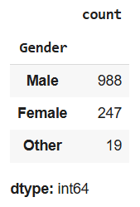
Check again if there is outlier for Age and Gender
print(df['Age'].unique())
[37 44 32 31 33 35 39 42 23 29 36 27 46 41 34 30 40 38 50 24 18 28 26 22
19 25 45 21 43 56 60 54 55 48 20 57 58 47 62 51 65 49 5 53 61 8 11 72]
print(df['Gender'].unique())
['Female' 'Male' 'Other']

Data Preparation
Change the NaN value in work_interfere to ‘Unsure’
df['work_interfere'] = df['work_interfere'].fillna('Unsure' )
print(df['work_interfere'].unique())
['Often' 'Rarely' 'Never' 'Sometimes' 'Unsure']

Change the NaN value in self_employment to ‘No’
df['self_employed'] = df['self_employed'].fillna('No')
print(df['self_employed'].unique())
['No' 'Yes']

Encoding Categorical Variables
input = ['Gender', 'self_employed', 'family_history', 'treatment',
'work_interfere', 'no_employees', 'remote_work', 'tech_company',
'benefits', 'care_options', 'wellness_program', 'seek_help',
'anonymity', 'leave', 'mental_health_consequence',
'phys_health_consequence', 'coworkers', 'supervisor',
'mental_health_interview', 'phys_health_interview',
'mental_vs_physical', 'obs_consequence']
label_encoder = LabelEncoder()

for col in input:
label_encoder.fit(df[col])
df[col] = label_encoder.transform(df[col])
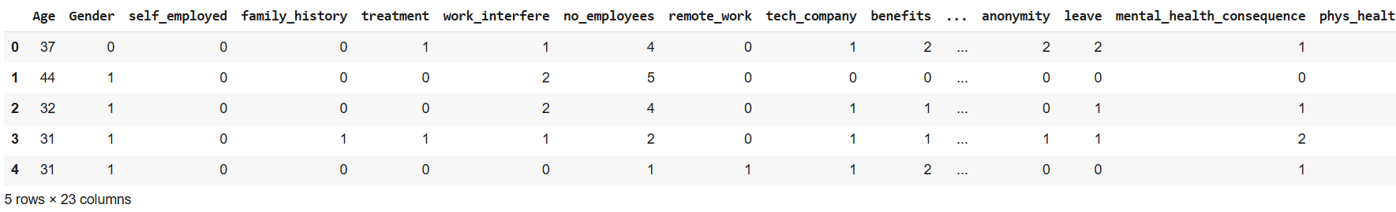

Scaling Age
scaler = MinMaxScaler()
df['Age'] = scaler.fit_transform(df[['Age']])
df.head()
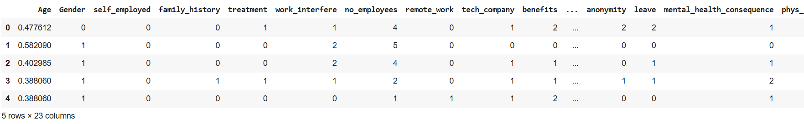

Correlation Matrix and Heatmap
corr_matrix = df.corr(numeric_only=True)
plt.figure(figsize=(15, 12))
sns.heatmap(corr_matrix, cmap="coolwarm", annot=False)
plt.title("Correlation Heatmap")
plt.show()
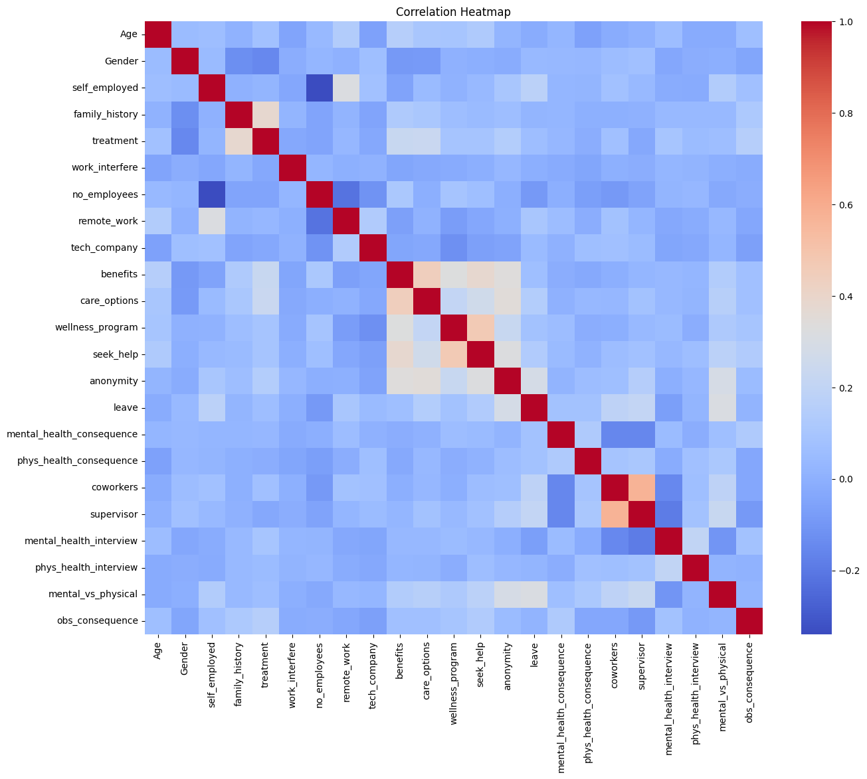

Model Development
feature_cols = ['Age', 'Gender', 'remote_work', 'tech_company', 'benefits', 'care_options', 'anonymity', 'mental_vs_physical', 'obs_consequence']
input = df[feature_cols]
target = df.work_interfere

X_train, X_test, y_train, y_test = train_test_split(input, target, test_size=0.30, random_state=42)

Feature selection
model = RandomForestClassifier(n_estimators=100, random_state=0)
model.fit(X_train, y_train)

feature_importances = pd.Series(model.feature_importances_, index=input.columns)

top_10_features = feature_importances.nlargest(10)

plt.figure(figsize=(10, 6))
top_10_features.plot(kind='bar')
plt.title('Top 10 Feature Importances')
plt.ylabel('Importance')
plt.xlabel('Feature')
plt.xticks(rotation=45, ha='right')
plt.tight_layout()
plt.show()

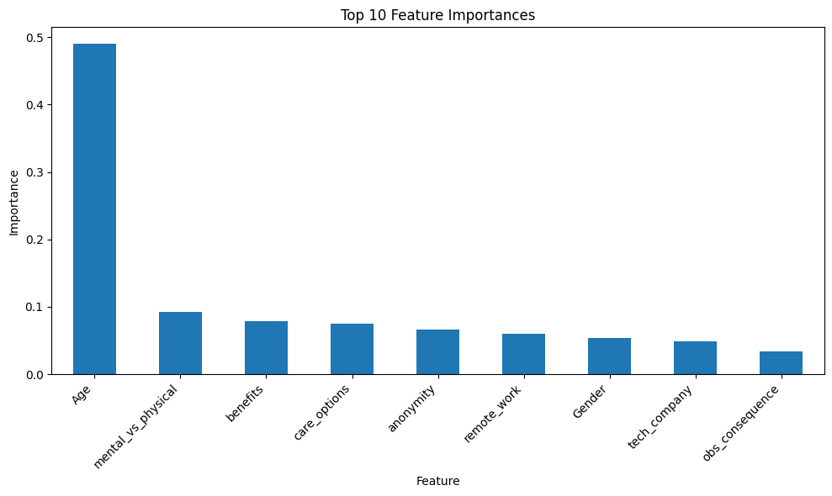

care_options

Logistic Regression
logreg = LogisticRegression()
logreg.fit(X_train, y_train)

y_pred_logreg = logreg.predict(X_test)

# Evaluate the model
accuracy_logreg = accuracy_score(y_test, y_pred_logreg)
precision_logreg = precision_score(y_test, y_pred_logreg, average='weighted')
f1_logreg = f1_score(y_test, y_pred_logreg, average='weighted')

print(f"Logistic Regression Accuracy: {accuracy_logreg:.4f}")
print(f"Logistic Regression Precision: {precision_logreg:.4f}")
print(f"Logistic Regression F1-score: {f1_logreg:.4f}")

# Confusion Matrix
cm_logreg = confusion_matrix(y_test, y_pred_logreg)
disp_logreg = ConfusionMatrixDisplay(confusion_matrix=cm_logreg, display_labels=logreg.classes_)
disp_logreg.plot(cmap=plt.cm.Blues)
plt.title('Logistic Regression Confusion Matrix')
plt.show()
====== Logistic Regression ======
Accuracy: 0.5252
Precision: 0.4998
F1-score: 0.4666
Recall: 0.5252
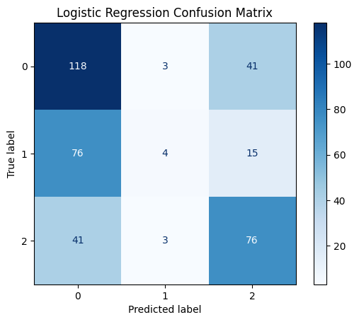

Decision Tree
dtree = DecisionTreeClassifier()
dtree.fit(X_train, y_train)

y_pred_dtree = dtree.predict(X_test)

# Evaluate the model
accuracy_dtree = accuracy_score(y_test, y_pred_dtree)
precision_dtree = precision_score(y_test, y_pred_dtree, average='weighted')
f1_dtree = f1_score(y_test, y_pred_dtree, average='weighted')
recall_dtree = recall_score(y_test, y_pred_dtree, average='weighted')

print('====== Decision Tree ======')
print(f" Accuracy: {accuracy_dtree:.4f}")
print(f" Precision: {precision_dtree:.4f}")
print(f" F1-score: {f1_dtree:.4f}")
print(f" Recall: {recall_dtree:.4f}")

# Confusion Matrix
cm_dtree = confusion_matrix(y_test, y_pred_dtree)
disp_dtree = ConfusionMatrixDisplay(confusion_matrix=cm_dtree, display_labels=dtree.classes_)
disp_dtree.plot(cmap=plt.cm.Blues)
plt.title('Decision Tree Confusion Matrix')
plt.show()
====== Decision Tree ======
Accuracy: 0.4828
Precision: 0.4814
F1-score: 0.4810
Recall: 0.4828
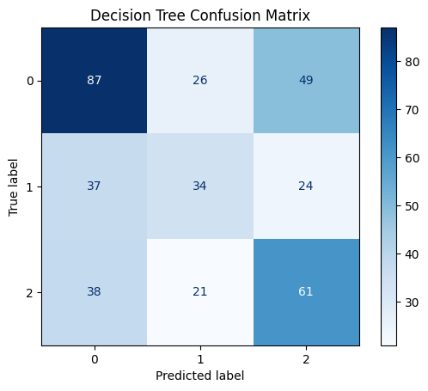

Random Forest
rf_model = RandomForestClassifier(n_estimators=100, random_state=0)
rf_model.fit(X_train, y_train)

y_pred_rf = rf_model.predict(X_test)

# Evaluate the model
accuracy_rf = accuracy_score(y_test, y_pred_rf)
precision_rf = precision_score(y_test, y_pred_rf, average='weighted')
f1_rf = f1_score(y_test, y_pred_rf, average='weighted')
recall_rf = recall_score(y_test, y_pred_rf, average='weighted')

print('====== Random Forest ======')
print(f" Accuracy: {accuracy_rf:.4f}")
print(f" Precision: {precision_rf:.4f}")
print(f" Recall: {recall_rf:.4f}")
print(f" F1-score: {f1_rf:.4f}")

# Confusion Matrix
cm_rf = confusion_matrix(y_test, y_pred_rf)
disp_rf = ConfusionMatrixDisplay(confusion_matrix=cm_rf, display_labels=rf_model.classes_)
disp_rf.plot(cmap=plt.cm.Blues)
plt.title('Random Forest Confusion Matrix')
plt.show()
====== Random Forest ======
Accuracy: 0.4801
Precision: 0.4781
Recall: 0.4801
F1-score: 0.4779
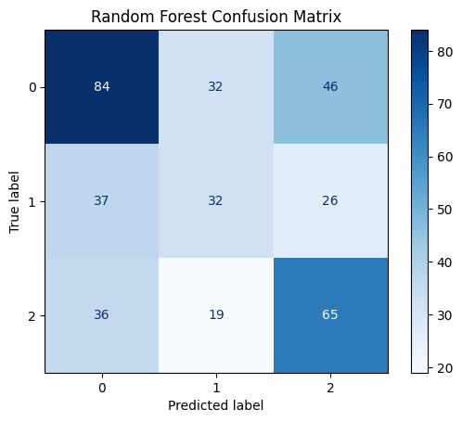

Comparison between Models
results_df = pd.DataFrame({
'Model': ['Logistic Regression', 'Decision Tree', 'Random Forest'],
'Accuracy': [accuracy_logreg, accuracy_dtree, accuracy_rf],
'Precision': [precision_logreg, precision_dtree, precision_rf],
'F1-score': [f1_logreg, f1_dtree, f1_rf],
'Recall': [recall_logreg, recall_dtree, recall_rf]
})

print("Model Comparison Table:")
print(results_df.to_string(index=False))

results_melted = results_df.melt('Model', var_name='Metric', value_name='Score')
plt.figure(figsize=(12, 7))
sns.barplot(x='Model', y='Score', hue='Metric', data=results_melted)
plt.title('Comparison of Model Performance Metrics')
plt.ylabel('Score')
plt.ylim(0, 1)
plt.show()

Model Accuracy Precision F1-score Recall
Logistic Regression 0.525199 0.499829 0.466635 0.525199
Decision Tree 0.482759 0.481441 0.481014 0.482759
Random Forest 0.480106 0.478080 0.477916 0.480106

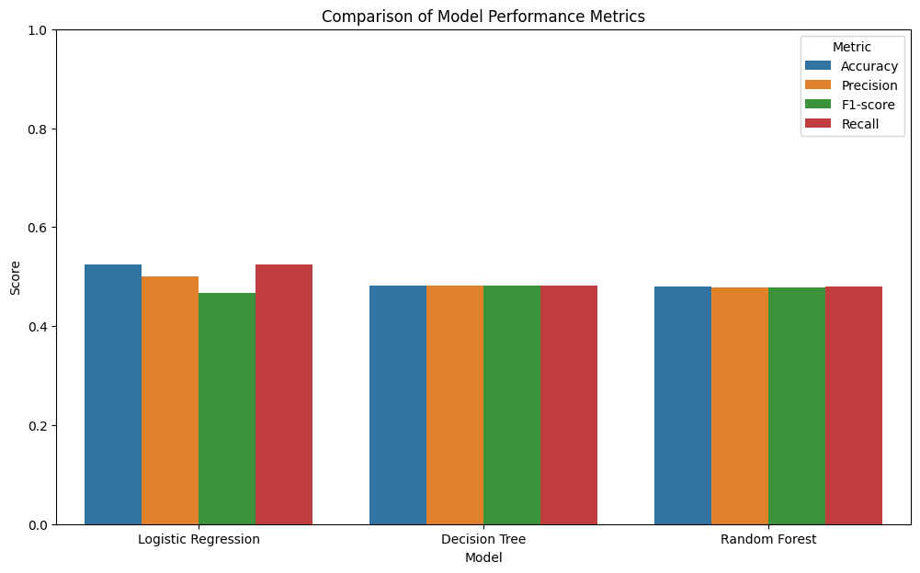

treatment
target = df.treatment
X_train, X_test, y_train, y_test = train_test_split(input, target, test_size=0.30, random_state=42)

Logistic Regression
logreg = LogisticRegression()
logreg.fit(X_train, y_train)

y_pred_logreg = logreg.predict(X_test)

# Evaluate the model
accuracy_logreg = accuracy_score(y_test, y_pred_logreg)
precision_logreg = precision_score(y_test, y_pred_logreg, average='weighted')
f1_logreg = f1_score(y_test, y_pred_logreg, average='weighted')
recall_logreg = recall_score(y_test, y_pred_logreg, average='weighted')

print('====== Logistic Regression ======')
print(f" Accuracy: {accuracy_logreg:.4f}")
print(f" Precision: {precision_logreg:.4f}")
print(f" F1-score: {f1_logreg:.4f}")
print(f" Recall: {recall_logreg:.4f}")

# Confusion Matrix
cm_logreg = confusion_matrix(y_test, y_pred_logreg)
disp_logreg = ConfusionMatrixDisplay(confusion_matrix=cm_logreg, display_labels=logreg.classes_)
disp_logreg.plot(cmap=plt.cm.Blues)
plt.title('Logistic Regression Confusion Matrix')
plt.show()
====== Logistic Regression ======
Accuracy: 0.6021
Precision: 0.6139
F1-score: 0.6011
Recall: 0.6021
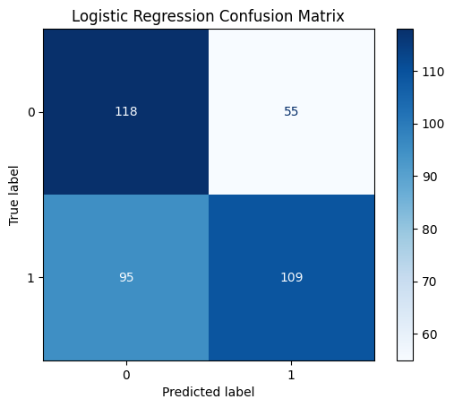

Decision Tree
dtree = DecisionTreeClassifier()
dtree.fit(X_train, y_train)

y_pred_dtree = dtree.predict(X_test)

# Evaluate the model
accuracy_dtree = accuracy_score(y_test, y_pred_dtree)
precision_dtree = precision_score(y_test, y_pred_dtree, average='weighted')
f1_dtree = f1_score(y_test, y_pred_dtree, average='weighted')
recall_dtree = recall_score(y_test, y_pred_dtree, average='weighted')

print('====== Decision Tree ======')
print(f" Accuracy: {accuracy_dtree:.4f}")
print(f" Precision: {precision_dtree:.4f}")
print(f" F1-score: {f1_dtree:.4f}")
print(f" Recall: {recall_dtree:.4f}")

# Confusion Matrix
cm_dtree = confusion_matrix(y_test, y_pred_dtree)
disp_dtree = ConfusionMatrixDisplay(confusion_matrix=cm_dtree, display_labels=dtree.classes_)
disp_dtree.plot(cmap=plt.cm.Blues)
plt.title('Decision Tree Confusion Matrix')
plt.show()
====== Decision Tree ======
Accuracy: 0.5438
Precision: 0.5482
F1-score: 0.5445
Recall: 0.5438
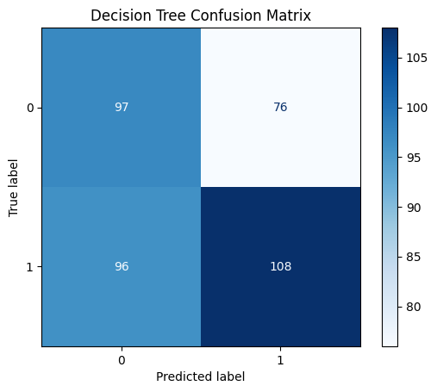

Random Forest
rf_model = RandomForestClassifier(n_estimators=100, random_state=0)
rf_model.fit(X_train, y_train)

y_pred_rf = rf_model.predict(X_test)

# Evaluate the model
accuracy_rf = accuracy_score(y_test, y_pred_rf)
precision_rf = precision_score(y_test, y_pred_rf, average='weighted')
f1_rf = f1_score(y_test, y_pred_rf, average='weighted')
recall_rf = recall_score(y_test, y_pred_rf, average='weighted')

print('====== Random Forest ======')
print(f" Accuracy: {accuracy_rf:.4f}")
print(f" Precision: {precision_rf:.4f}")
print(f" Recall: {recall_rf:.4f}")
print(f" F1-score: {f1_rf:.4f}")

# Confusion Matrix
cm_rf = confusion_matrix(y_test, y_pred_rf)
disp_rf = ConfusionMatrixDisplay(confusion_matrix=cm_rf, display_labels=rf_model.classes_)
disp_rf.plot(cmap=plt.cm.Blues)
plt.title('Random Forest Confusion Matrix')
plt.show()
====== Random Forest ======
Accuracy: 0.6021
Precision: 0.6067
Recall: 0.6021
F1-score: 0.6027
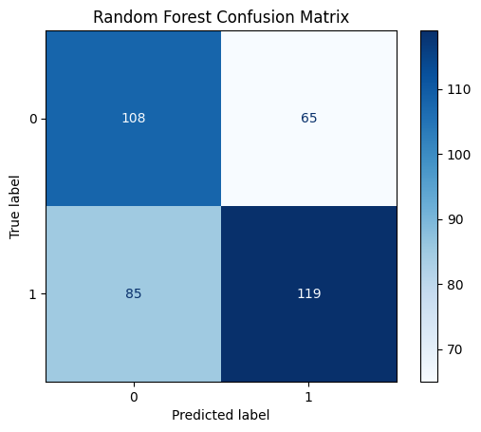

Comparison between Models
results_df = pd.DataFrame({
'Model': ['Logistic Regression', 'Decision Tree', 'Random Forest'],
'Accuracy': [accuracy_logreg, accuracy_dtree, accuracy_rf],
'Precision': [precision_logreg, precision_dtree, precision_rf],
'F1-score': [f1_logreg, f1_dtree, f1_rf],
'Recall': [recall_logreg, recall_dtree, recall_rf]
})

print(results_df.to_string(index=False))

results_melted = results_df.melt('Model', var_name='Metric', value_name='Score')
plt.figure(figsize=(12, 7))
sns.barplot(x='Model', y='Score', hue='Metric', data=results_melted)
plt.title('Comparison of Model Performance Metrics')
plt.ylabel('Score')
plt.ylim(0, 1)
plt.show()

Model Accuracy Precision F1-score Recall
Logistic Regression 0.602122 0.613861 0.601114 0.602122
Decision Tree 0.543767 0.548242 0.544473 0.543767
Random Forest 0.602122 0.606746 0.602738 0.602122

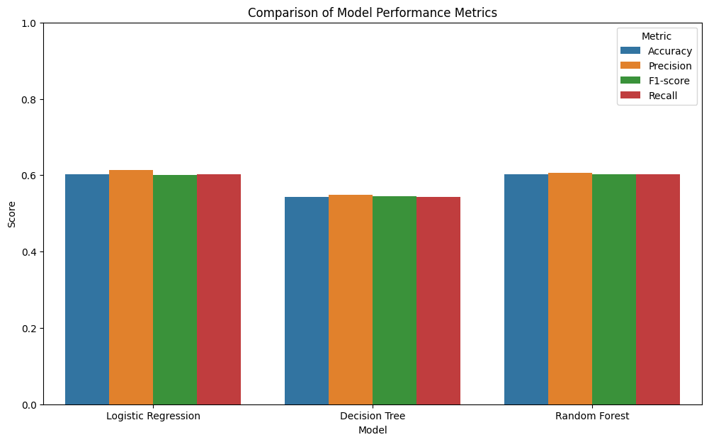

family_history
target = df.family_history
X_train, X_test, y_train, y_test = train_test_split(input, target, test_size=0.30, random_state=42)

Logistic Regression
logreg = LogisticRegression()
logreg.fit(X_train, y_train)

y_pred_logreg = logreg.predict(X_test)

# Evaluate the model
accuracy_logreg = accuracy_score(y_test, y_pred_logreg)
precision_logreg = precision_score(y_test, y_pred_logreg, average='weighted')
f1_logreg = f1_score(y_test, y_pred_logreg, average='weighted')
recall_logreg = recall_score(y_test, y_pred_logreg, average='weighted')

print('====== Logistic Regression ======')
print(f" Accuracy: {accuracy_logreg:.4f}")
print(f" Precision: {precision_logreg:.4f}")
print(f" F1-score: {f1_logreg:.4f}")
print(f" Recall: {recall_logreg:.4f}")

# Confusion Matrix
cm_logreg = confusion_matrix(y_test, y_pred_logreg)
disp_logreg = ConfusionMatrixDisplay(confusion_matrix=cm_logreg, display_labels=logreg.classes_)
disp_logreg.plot(cmap=plt.cm.Blues)
plt.title('Logistic Regression Confusion Matrix')
plt.show()
====== Logistic Regression ======
Accuracy: 0.6446
Precision: 0.6459
F1-score: 0.5727
Recall: 0.6446
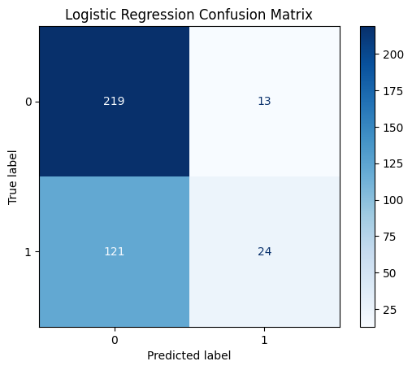

Decision Tree
dtree = DecisionTreeClassifier()
dtree.fit(X_train, y_train)

y_pred_dtree = dtree.predict(X_test)

# Evaluate the model
accuracy_dtree = accuracy_score(y_test, y_pred_dtree)
precision_dtree = precision_score(y_test, y_pred_dtree, average='weighted')
f1_dtree = f1_score(y_test, y_pred_dtree, average='weighted')
recall_dtree = recall_score(y_test, y_pred_dtree, average='weighted')

print('====== Decision Tree ======')
print(f" Accuracy: {accuracy_dtree:.4f}")
print(f" Precision: {precision_dtree:.4f}")
print(f" F1-score: {f1_dtree:.4f}")
print(f" Recall: {recall_dtree:.4f}")

# Confusion Matrix
cm_dtree = confusion_matrix(y_test, y_pred_dtree)
disp_dtree = ConfusionMatrixDisplay(confusion_matrix=cm_dtree, display_labels=dtree.classes_)
disp_dtree.plot(cmap=plt.cm.Blues)
plt.title('Decision Tree Confusion Matrix')
plt.show()
====== Decision Tree ======
Accuracy: 0.5517
Precision: 0.5430
F1-score: 0.5465
Recall: 0.5517
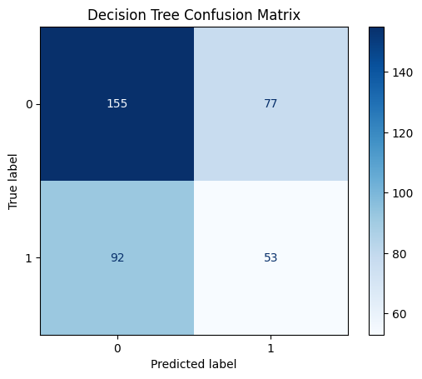

Random Forest
rf_model = RandomForestClassifier(n_estimators=100, random_state=0)
rf_model.fit(X_train, y_train)

y_pred_rf = rf_model.predict(X_test)

# Evaluate the model
accuracy_rf = accuracy_score(y_test, y_pred_rf)
precision_rf = precision_score(y_test, y_pred_rf, average='weighted')
f1_rf = f1_score(y_test, y_pred_rf, average='weighted')
recall_rf = recall_score(y_test, y_pred_rf, average='weighted')

print('====== Random Forest ======')
print(f" Accuracy: {accuracy_rf:.4f}")
print(f" Precision: {precision_rf:.4f}")
print(f" Recall: {recall_rf:.4f}")
print(f" F1-score: {f1_rf:.4f}")

# Confusion Matrix
cm_rf = confusion_matrix(y_test, y_pred_rf)
disp_rf = ConfusionMatrixDisplay(confusion_matrix=cm_rf, display_labels=rf_model.classes_)
disp_rf.plot(cmap=plt.cm.Blues)
plt.title('Random Forest Confusion Matrix')
plt.show()
====== Random Forest ======
Accuracy: 0.5623
Precision: 0.5539
Recall: 0.5623
F1-score: 0.5573
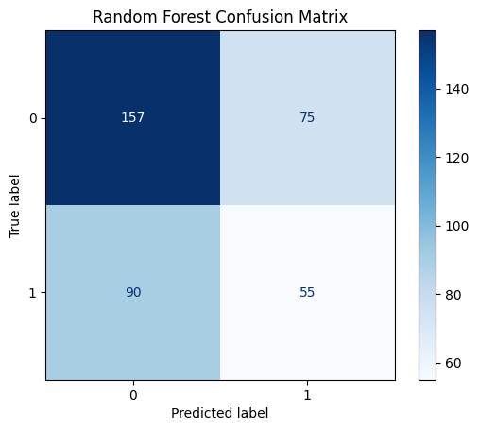

Comparison between Models
results_df = pd.DataFrame({
'Model': ['Logistic Regression', 'Decision Tree', 'Random Forest'],
'Accuracy': [accuracy_logreg, accuracy_dtree, accuracy_rf],
'Precision': [precision_logreg, precision_dtree, precision_rf],
'F1-score': [f1_logreg, f1_dtree, f1_rf],
'Recall': [recall_logreg, recall_dtree, recall_rf]
})

print(results_df.to_string(index=False))

results_melted = results_df.melt('Model', var_name='Metric', value_name='Score')
plt.figure(figsize=(12, 7))
sns.barplot(x='Model', y='Score', hue='Metric', data=results_melted)
plt.title('Comparison of Model Performance Metrics')
plt.ylabel('Score')
plt.ylim(0, 1)
plt.show()
Model Accuracy Precision F1-score Recall
Logistic Regression 0.644562 0.645860 0.572658 0.644562
Decision Tree 0.551724 0.542977 0.546517 0.551724
Random Forest 0.562334 0.553877 0.557251 0.562334

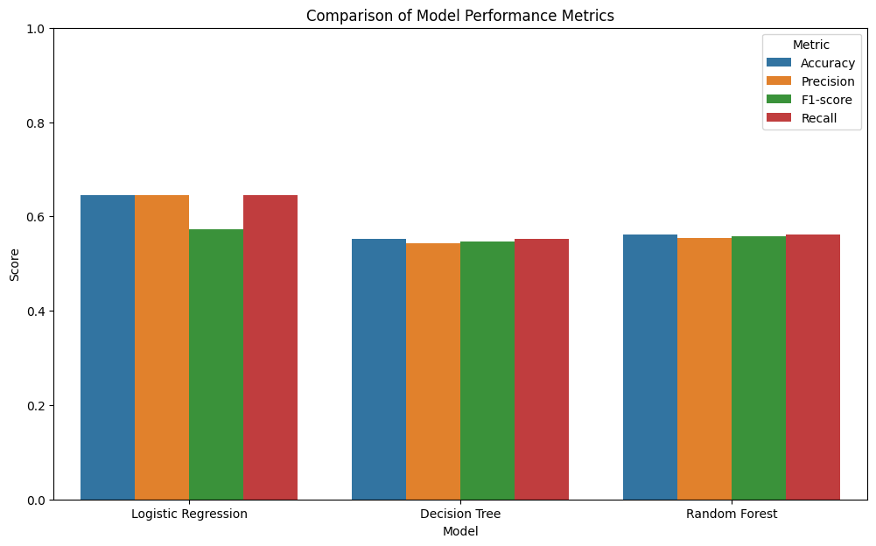

Model Performance and Evaluation
The performance of the three classification models – Logistic Regression, Decision Tree, and Random Forest was evaluated across three target variables:
- care_options
Logistic Regression | Highest accuracy (52.52%) and precision (49.98%), but the F1-score (46.66%) indicated moderate performance in balancing precision and recall
Decision Tree | Performed moderately with an accuracy of 48.28% and an F1-score of 48.10%
Random Forest | Similar performance to the Decision Tree with an accuracy of 48.01% and an F1-score of 47.79%
Logistic Regression perform better than the other models for this target variable. It showed that a linear approach may better capture the relationship between the features and the availability of care options the employer provides.
- treatment
Logistic Regression | Achieved an accuracy of 60.21% and an F1-score of 60.11%
Decision Tree | Lower accuracy (54.38%) and F1-score (54.45%), weaker predictive capability
Random Forest | Similar performance to the Decision Tree with an accuracy (60.21%) and F1-score (60.27%)
Random Forest performed well for predicting treatment-seeking behaviour. It showed that the model is suitable for binary classification tasks.
- family_history
Logistic Regression | Highest accuracy (64.46%) and F1-score (57.27%), indicated moderate performance in balancing precision and recall
Decision Tree | Perform moderately with an accuracy of 55.17% and an F1-score of 54.65%
Random Forest | Slightly improved than the Decision Tree with an accuracy of 56.23% and an F1-score of 55.73%
Logistic Regression was the most effective model for predicting the influence of family history on mental health, likely due to the linear relationships in the data.

Conclusion
In this project, we used Python to study how mental health affects tech workers. We tried to predict three important things - how much care options provided by the employers affects people, if people get treatment, and if family history affect the workers’ mental health as well. We used three different prediction method – Logistic Regression, Decision Tree, and Random Forest.
The analysis was pretty good at predicting if someone would get treatment (about 60% accurate) and if family history was important (64% right). The Logistic Regression method worked best for these. But predicting how much care options provided by the employers to the worker was harder. The prediction only got it right about half the time. This might be because people's feelings at work are more complicated to measure.
We learned that things like age, whether you work from home, and what your company offers for mental health help were the biggest clues for the prediction. Just like how older people might be more likely to get treatment, or people who work from home might feel less stressed.
One problem was that some answers were missing in our datasets, like when people didn't say how mental health affects their work. Also, some groups of people answered more than others, which made it harder for the model to learn. In the future, we could try better ways to fill in missing data or use stronger prediction methods like XGBoost.
Even though our predictions aren't perfect yet, they show we can use technology to help understand mental health at work. If we keep improving them, maybe one day they can help companies make better rules to keep their workers happy and healthy.

References
Breiman, L. (2001). Random Forests. Machine Learning, 45(1), 5–32. https://doi.org/10.1023/a:1010933404324
GuyonIsabelle, & ElisseeffAndré. (2003). An introduction to variable and feature selection. Journal of Machine Learning Research. https://doi.org/10.5555/944919.944968
Hosmer, D. W., Lemeshow, S., & Sturdivant, R. X. (2013). Applied Logistic Regression. In Wiley series in probability and statistics. https://doi.org/10.1002/9781118548387
Mental Health in Tech survey. (2016, November 3). Kaggle. https://www.kaggle.com/datasets/osmi/mental-health-in-tech-survey
Safavian, S., & Landgrebe, D. (1991). A survey of decision tree classifier methodology. IEEE Transactions on Systems Man and Cybernetics, 21(3), 660–674. https://doi.org/10.1109/21.97458
VanderPlas, J. (2023). Python Data Science Handbook: Essential Tools for Working with Data. O’Reilly Media.

